Cross vali

Train test:

Train model

Test check accuracy

70,30- randomly selected

Do with diff random states

Rendom_state =30,20

Acturacy fluctuate as train and test data changes, accuracy fluctuate,

Cross validation:

**Leave one out cross validation:**

If I have 100o records

Exp1: 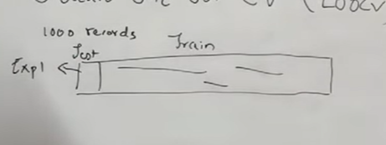

Exp2: 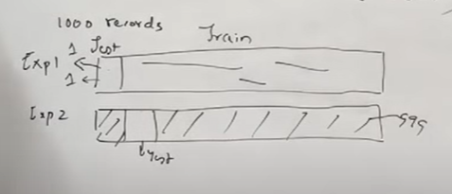

Many time we need to do iteration

Increases low bias

Test data good result

But whenever new data comes accuracy goes down

Now a days no one is using

:

2 type

Most frequently used

**K Fold CV:**

**If k =5**

**Means 5 exp/5 cross validations**

**Based on k value it decide test data**

**1000/5**

**Tested on 200- accuracy 1**

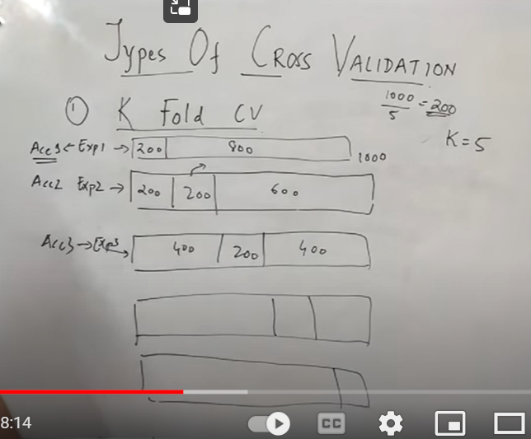

**This continue till all the iteration completes**

**Find avg**

**That’s ans**

**Also we can say**

**Min accuracy**

**Max accuracy**

**Drawback; if that dataset contains only one type data**

**That can be a problem**

**To solve that :**

**Stratified cross validation:**

**Whenever test data selected ,**

**No of instances of each class for each instance is taken properly**

**K=5**

**1000/5**

**--**

**Time series cross validation:**

**If data is of time series**

**We need to predict future data**

**We can split train and test 70, 30 randomly**



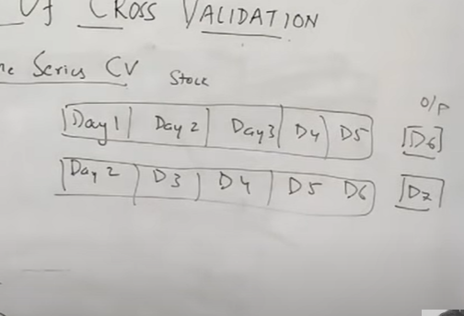

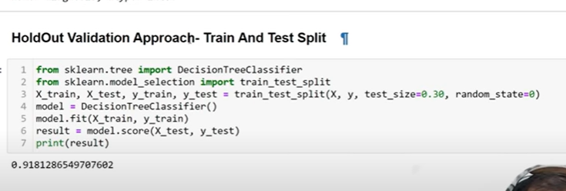

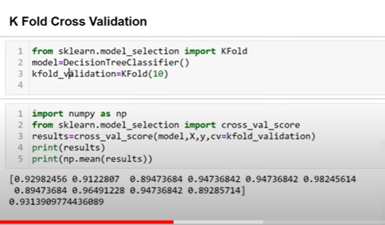

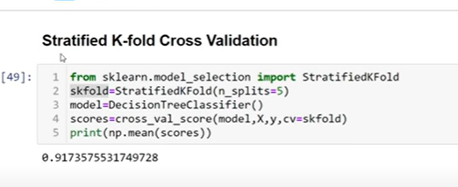

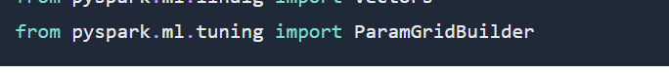

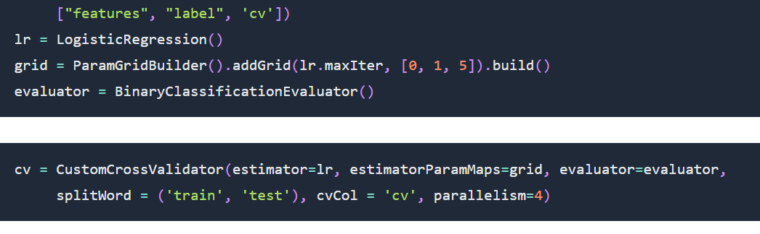

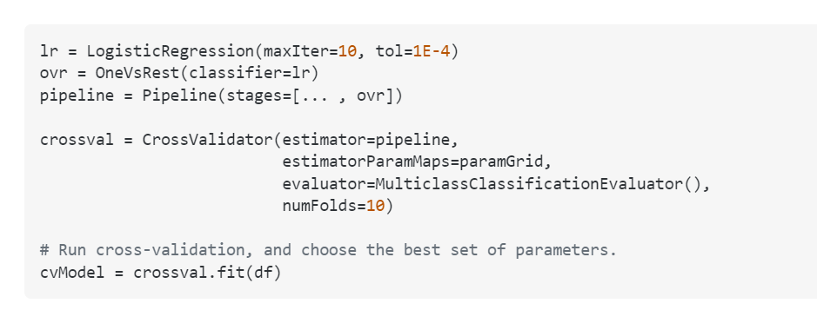

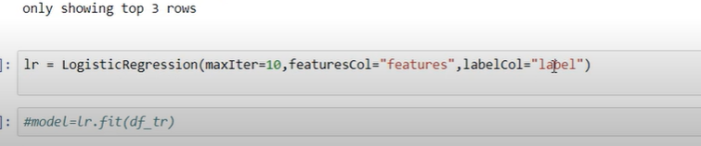

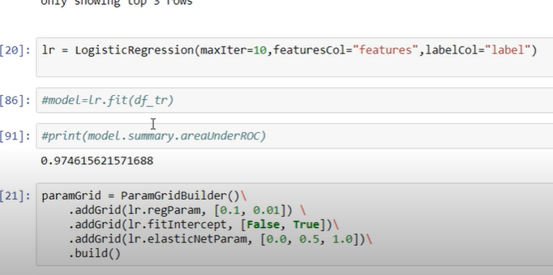

Estistc: l1 ,l2

Requlariz: any parameters shouldnot dominators

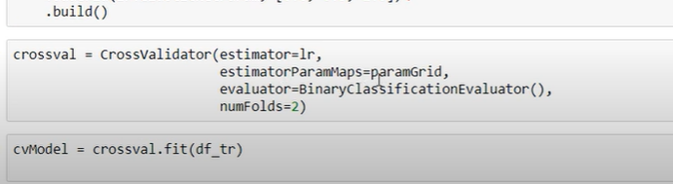

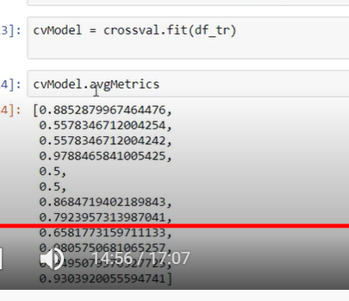

Hyper parameter tuning:

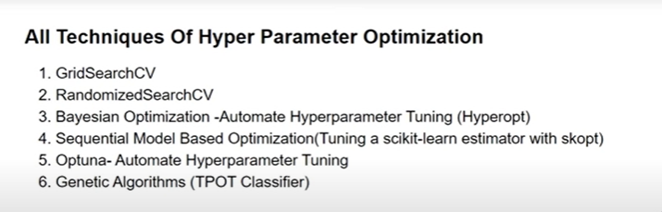

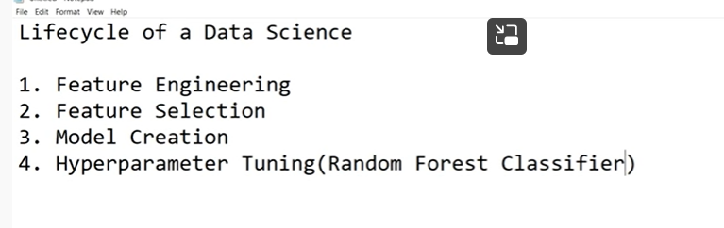

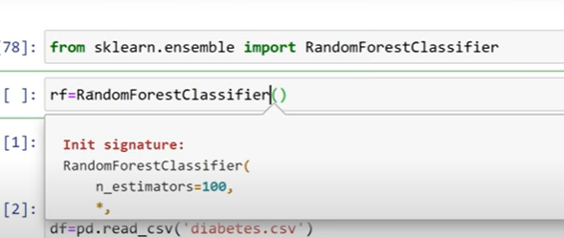

Shift tab

Gt gives all para

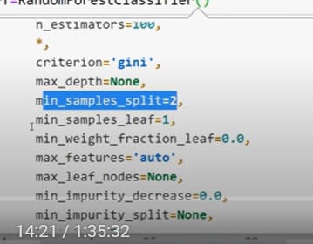

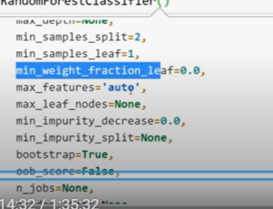

We need to check these values

Sowe cant guess

Cant Guess everything

We need to play with all and select best parameter

We need to tune and get optimum parameters

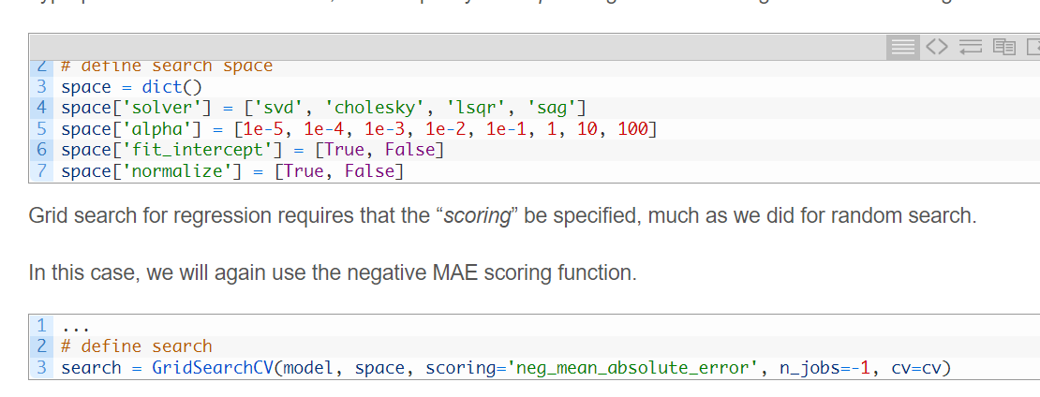

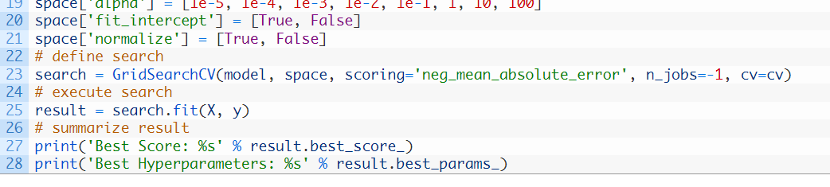

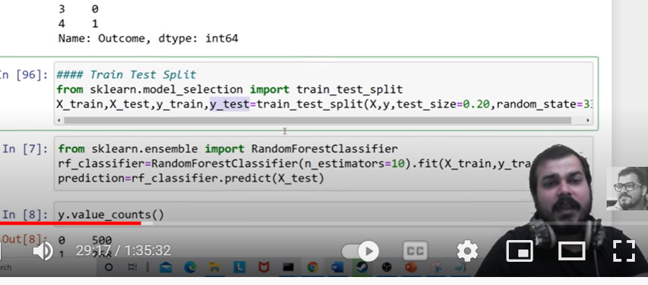

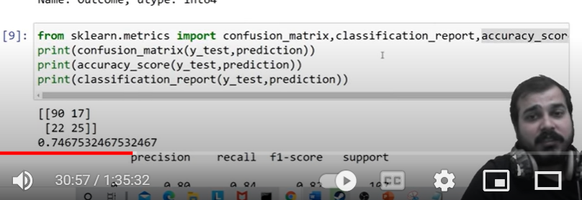

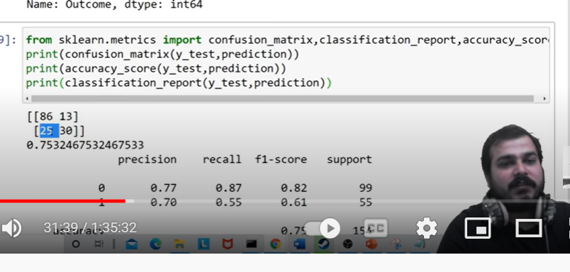

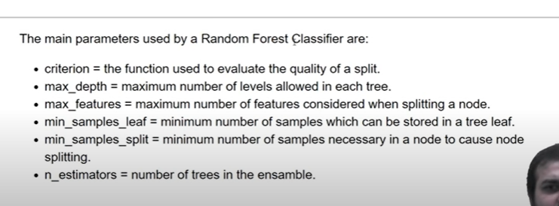

I do as I feel

manually

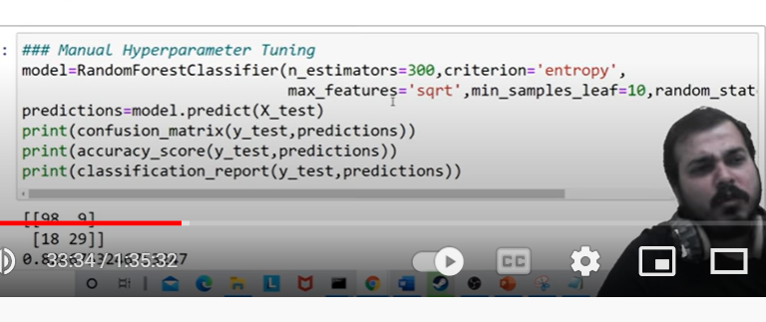

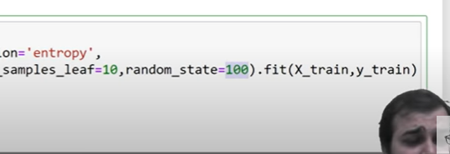

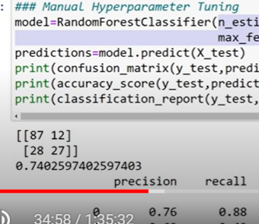

Accuracy is changing

These values shouldn’t be based on our interest

We need to do hyper- parame

Why one should I use?

gridsearchCV

randomizedsearchCV

GRIDSERCH:

It will go and check every area and says

Randomized Search:

Randomly search

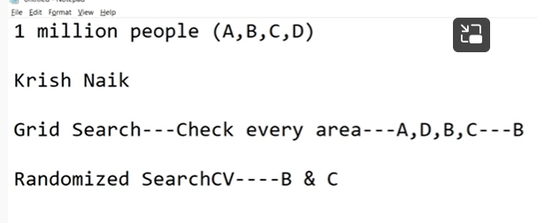

Which one should used 1st

Randomized

It will narrow down our result, when we got b and c

Then use gridserch : apply it to check whether in b and c

Gridseach takes all possible permutations and combinations

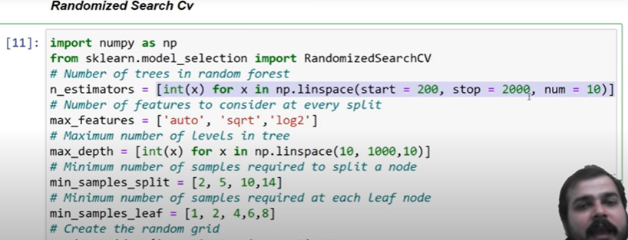

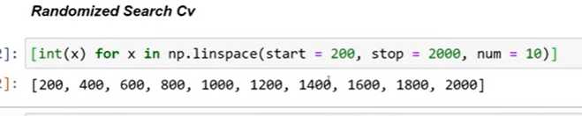

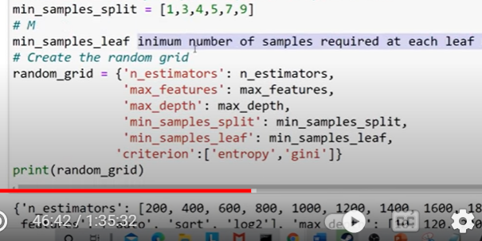

[All-Hyperparamter-Optimization/Hyper Parameter Optimization.ipynb at master · krishnaik06/All-Hyperparamter-Optimization (github.com)](https://github.com/krishnaik06/All-Hyperparamter-Optimization/blob/master/Hyper%20Parameter%20Optimization.ipynb)

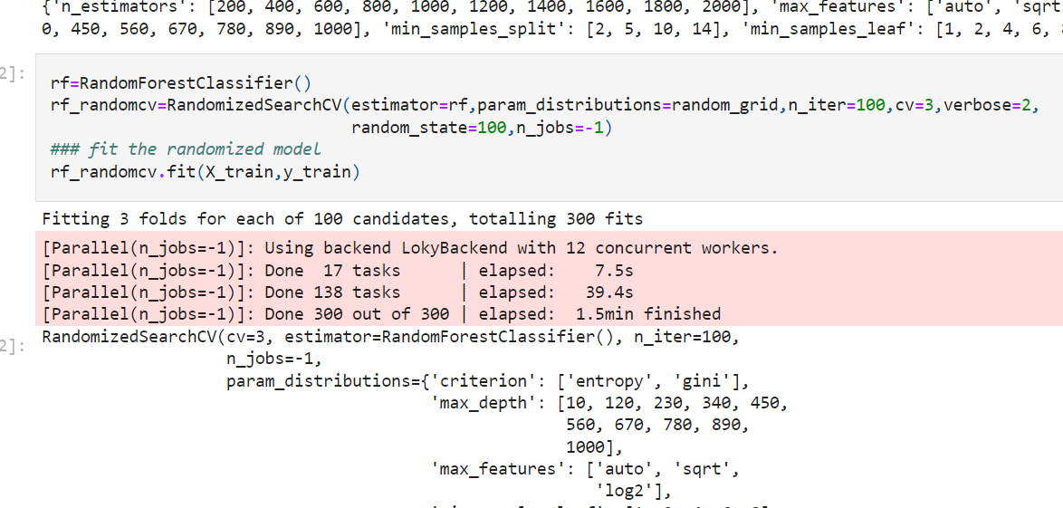

Cv: cross validation

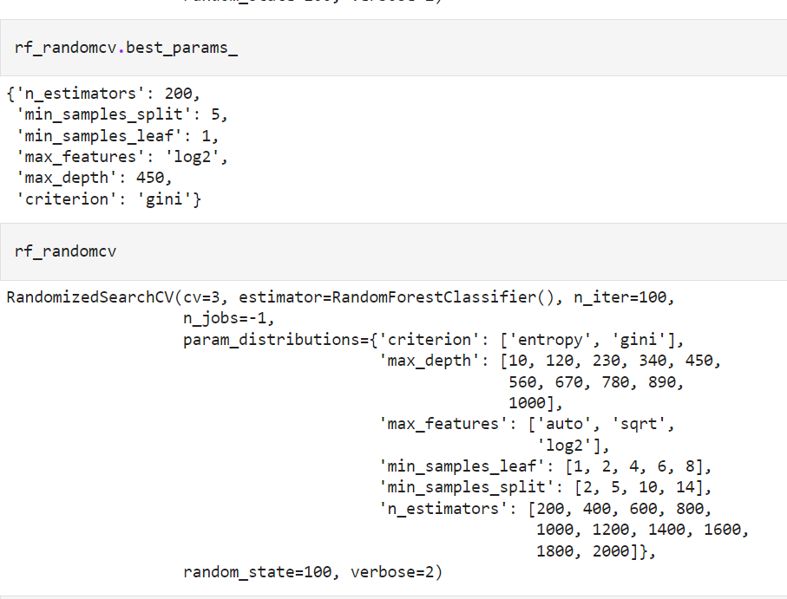

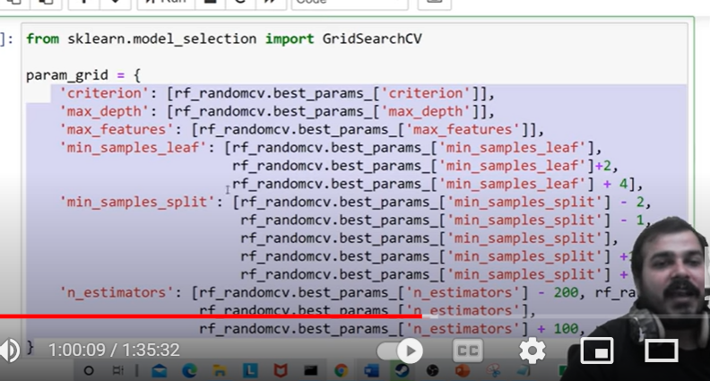

I need to start as key value pair

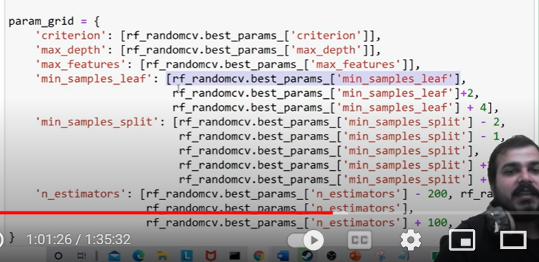

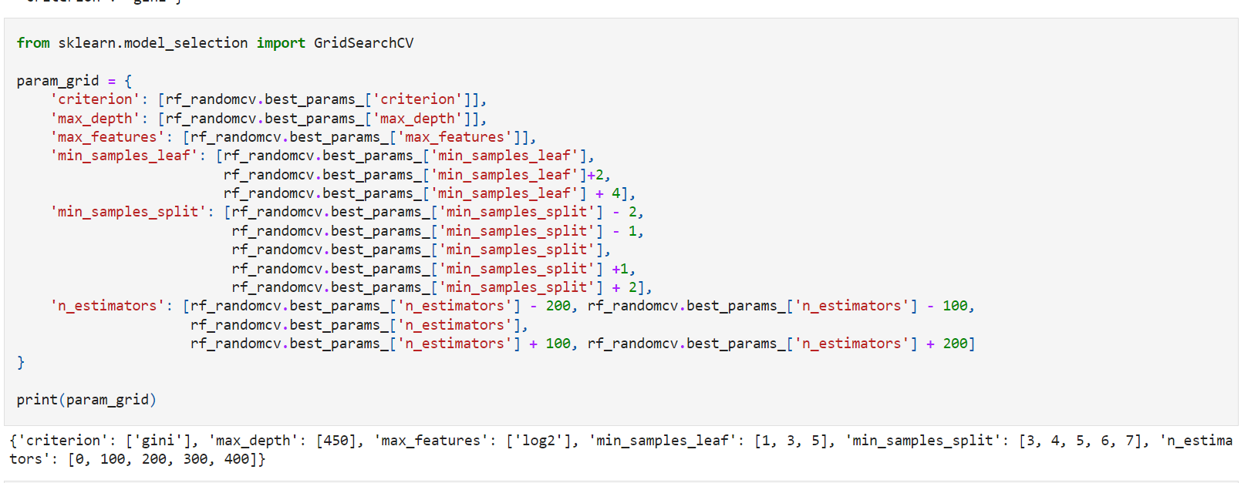

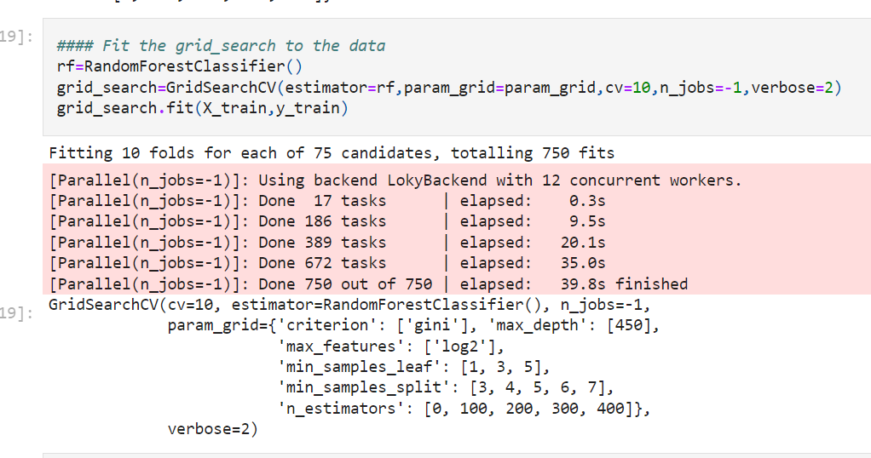

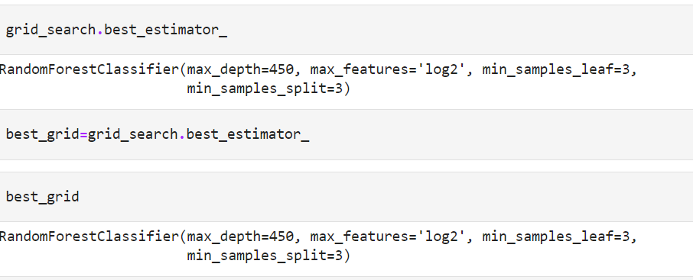

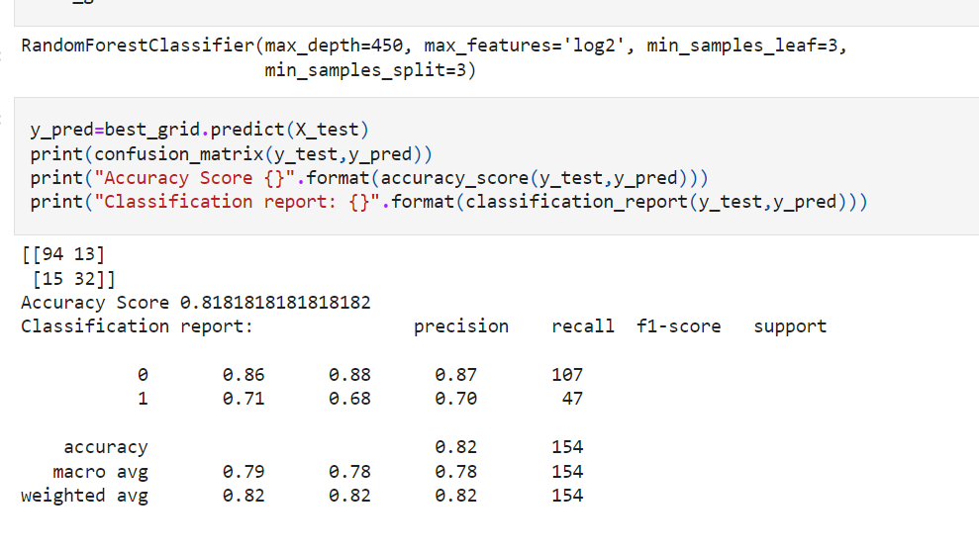

**Automated Hyperparameter Tuning**

Automated Hyperparameter Tuning can be done by using techniques such as

* Bayesian Optimization
* Gradient Descent
* Evolutionary Algorithms

**Bayesian Optimization**

Bayesian optimization uses **probability to find the minimum of a function**. The final aim is to find the **input value to a function** which can **gives us the lowest possible output value**.

It usually performs **better than random,grid and manual search** providing better performance in the **testing phase and reduced optimization time**.

In **Hyperopt, Bayesian Optimization** can be implemented giving 3 three main parameters to the function fmin.

* **Objective Function** = defines the **loss function** to minimize.
* **Domain Space** = **defines the range of input values to test** (in Bayesian Optimization this space creates a probability distribution for each of the used Hyperparameters).
* **Optimization Algorithm** = defines the **search algorithm to use to select the best input values** to use in each new iteration.

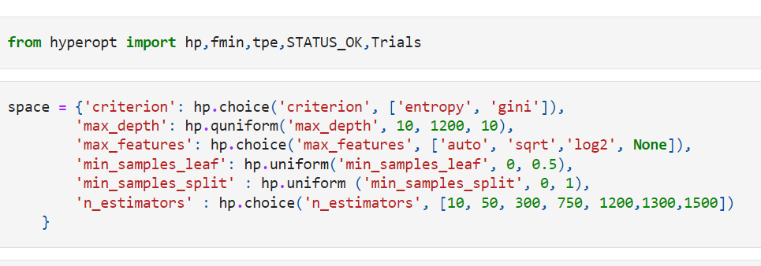

[All-Hyperparamter-Optimization/Hyper Parameter Optimization.ipynb at master · krishnaik06/All-Hyperparamter-Optimization (github.com)](https://github.com/krishnaik06/All-Hyperparamter-Optimization/blob/master/Hyper%20Parameter%20Optimization.ipynb)

